

A review of Outcome stars within Health Visiting Practice in Warwickshire

Author: Sam Game,
Clinical Lead for Health Visiting,
Star Lead for Warwickshire.

Date: Audit completed October 2020
Report summarised March 2021

Table of Contents
Introduction 2
Aim 3
Objectives 3
Method/ Improvement cycles 3
Results 4
1. Staff views on use of the outcome star 4
2. Parent views on using the Parent & Baby Outcome star 6
3. Staff views on the resources available to support the Outcome star implementation 8
4. Staff views on if the star were being used at the right time to capture the work effectively with parents. 8
Audit review findings/ Conclusions 9
Lessons Learnt/ Key Successes 10
Recommendations 10

Introduction

The Parent and Baby outcome star has been used to measure heath visiting impact within Warwickshire’s 0-5 Public health service since April 2019. Warwickshire are the first Health Visiting service nationally to use the Outcome star format within practice. There are over 40 different Outcome stars available from Triangle, which are used across a wide spectrum of services including Social Care, Youth Justice and Drug and Alcohol services. When implementing the Outcome star system, to ensure accurate and useful data, an agile implementation model with regular reviews was agreed upon.

At the beginning of 2019, all 115 Health Visitors within Warwickshire 0-5 public health nursing were trained in a joint training initiative with Triangle, the providers of the Outcome Star tool. This was the first time Triangle had delivered the outcome star training in such an integrated manner and it was deemed a success. Initially eight training sessions were completed, leading to 115 licenses being issued to staff.

The Standard operating procedures (SOPs) were written and agreed by senior management. This stated that the Parent and Baby Outcome star tool (see diagram 1) would be used with all parents, at the six week postnatal review. Health Visitors were already carrying out a 6 week review, so this ensured the tool’s implementation was operationally feasible. The parent and baby star is known as the outcome star for perinatal mental health and wellbeing. It contains 7 areas for review, including: mental and emotional health, physical health, housing and essentials, relationships, support networks, looking after your baby and connecting with your baby. It uses the principles of a journey of change (see Diagram 2) with a scale of 1 to 5. The scores at 6 weeks gave us two options: If families were scoring 4s and 5s in all areas they would receive just one star reading and the reading would be used to give us a point of need. If a parent scored three or below in any area, then an intervention would be offered, followed by a review star looking at levels of change. The type of intervention would be negioiated between the parent and the clinician at the time of the reading. Each star is extensively tested by Triangle, prior to publication and the guides, used by the trained staff, contain the appropriate language for the client group. The consistent use of questions and scoring also allows continuity within the score system e.g. a mum scoring 3 in Nuneaton would be showing the same concerns as a mum scoring 3 in Stratford.

Diagram 1: The Parent and Baby Star
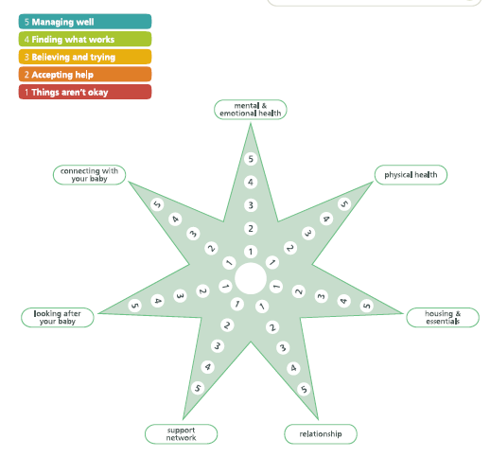
Diagram 2: The accompanying journey of change for the Parent and Baby star

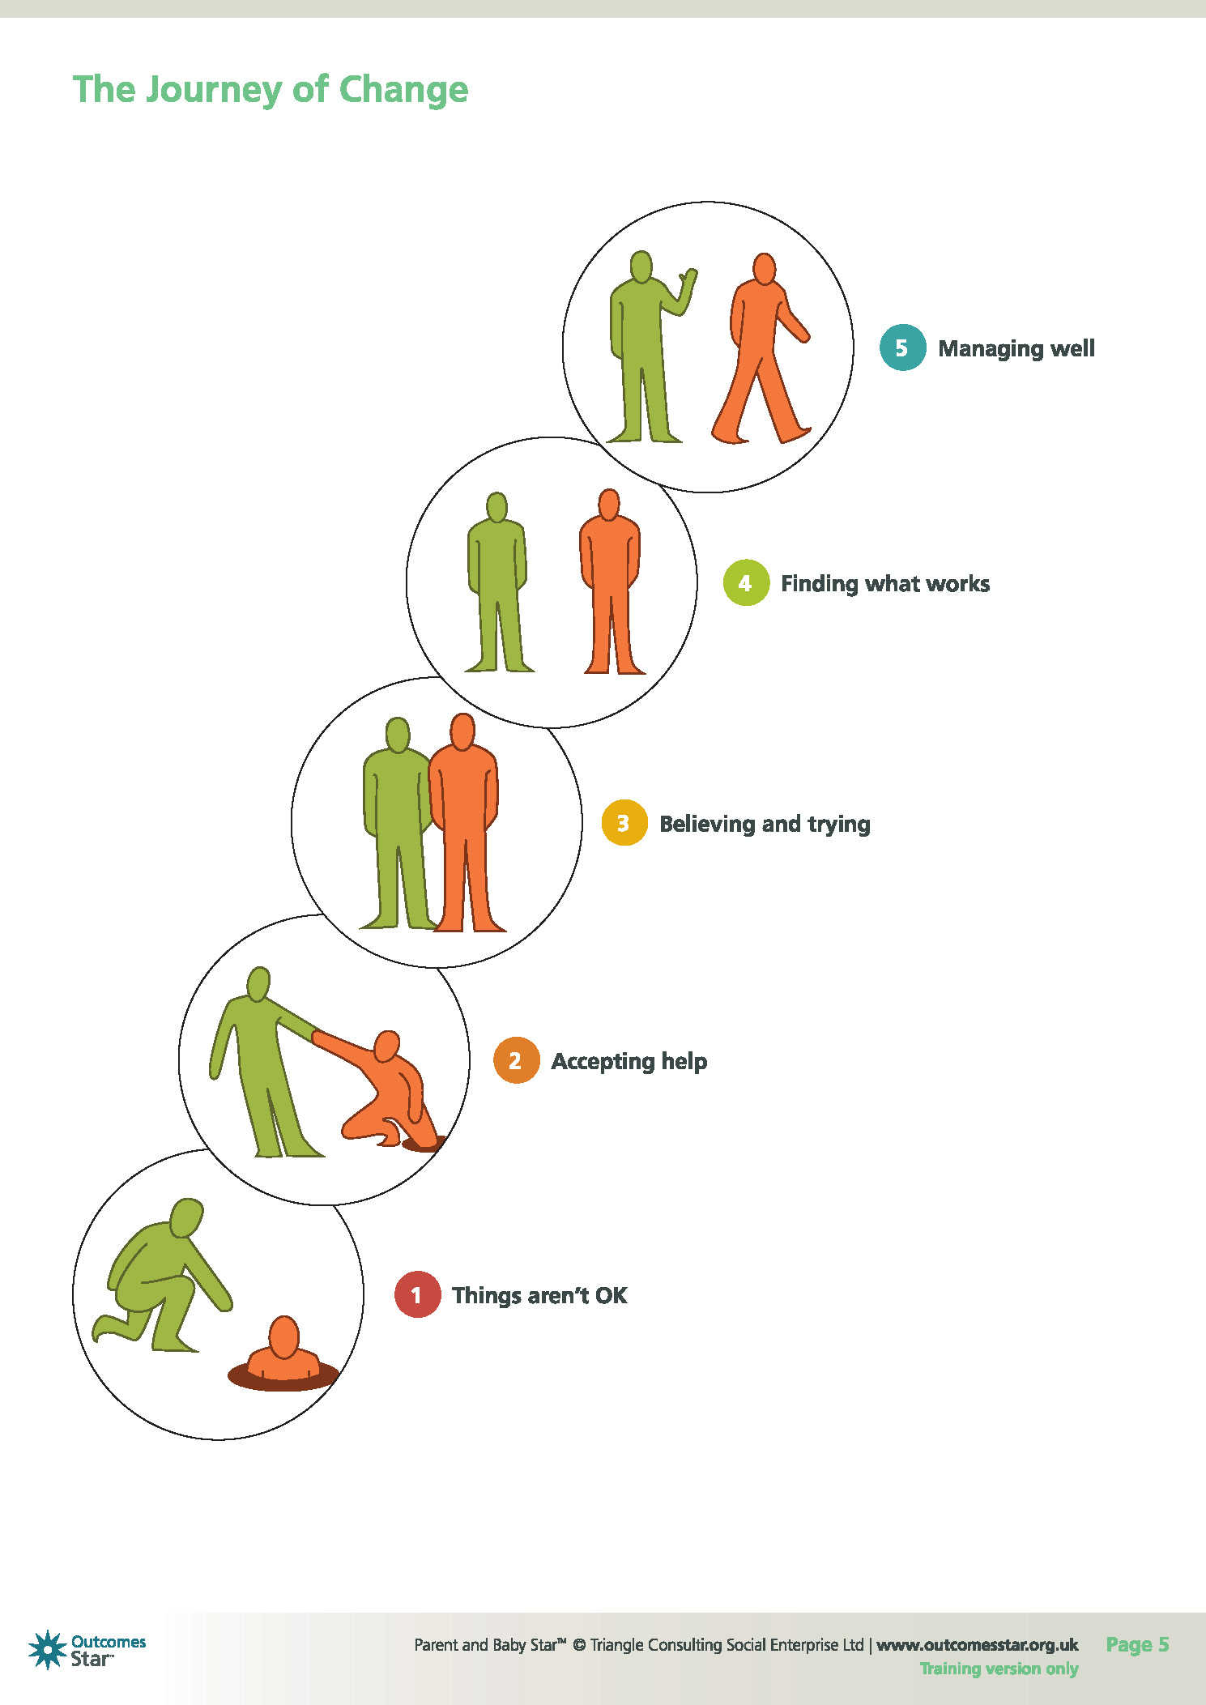

The first full audit was carried out with staff after they had used the Outcome stars for 1 year. This report has the information from that review along with recommendations for future practice following on from this.

Aim

The aim of the audit was to review how effective the Outcome star is from a staff and parent perspective.

Objectives

It aimed to assess:
- Staff views on the use of the outcome star:
- What parents’ views on the use of the star were
- Staff views on the resources available to help them share information about the outcome stars with parents.
- Staff views on the timing of the Outcome star reading, and whether a different time to complete the outcome star be more effective.

Method/ Improvement cycles
All staff, with active star licenses, were sent a google forms questionnaire to complete regarding their experiences and opinions of using the Parent and Baby star.
46 Health Visitors responded, giving a response rate of 42%.

Results
The following questions and results were found from the questionnaire:

Staff views on use of the outcome star

Of those questioned 98% Health visitors stated they used the Parent and Baby outcome star with families at the 6 week postnatal assessment.

When we asked if the outcome star allowed Health Visitors to get a clearer picture of the lived experience of the family the response can be seen in Diagram 3:

Diagram 3:
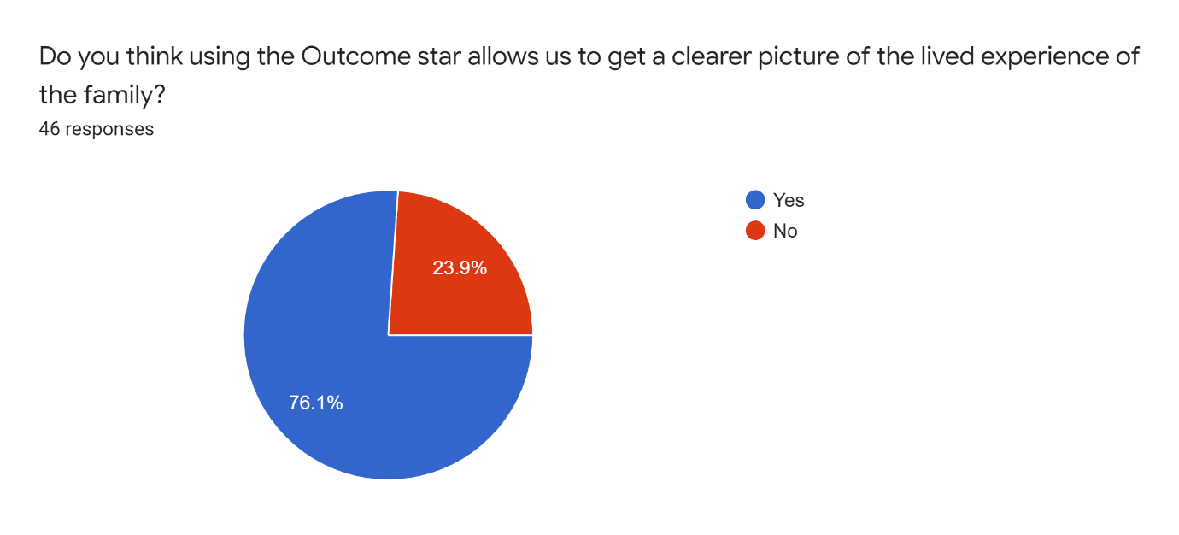
Yes= 45 No = 1

Showing that 76% of Health Visitors felt the Parent and Baby star gave them a clearer picture of the lived experience of the family.

Diagram 4: Would you recommend using Outcome stars?
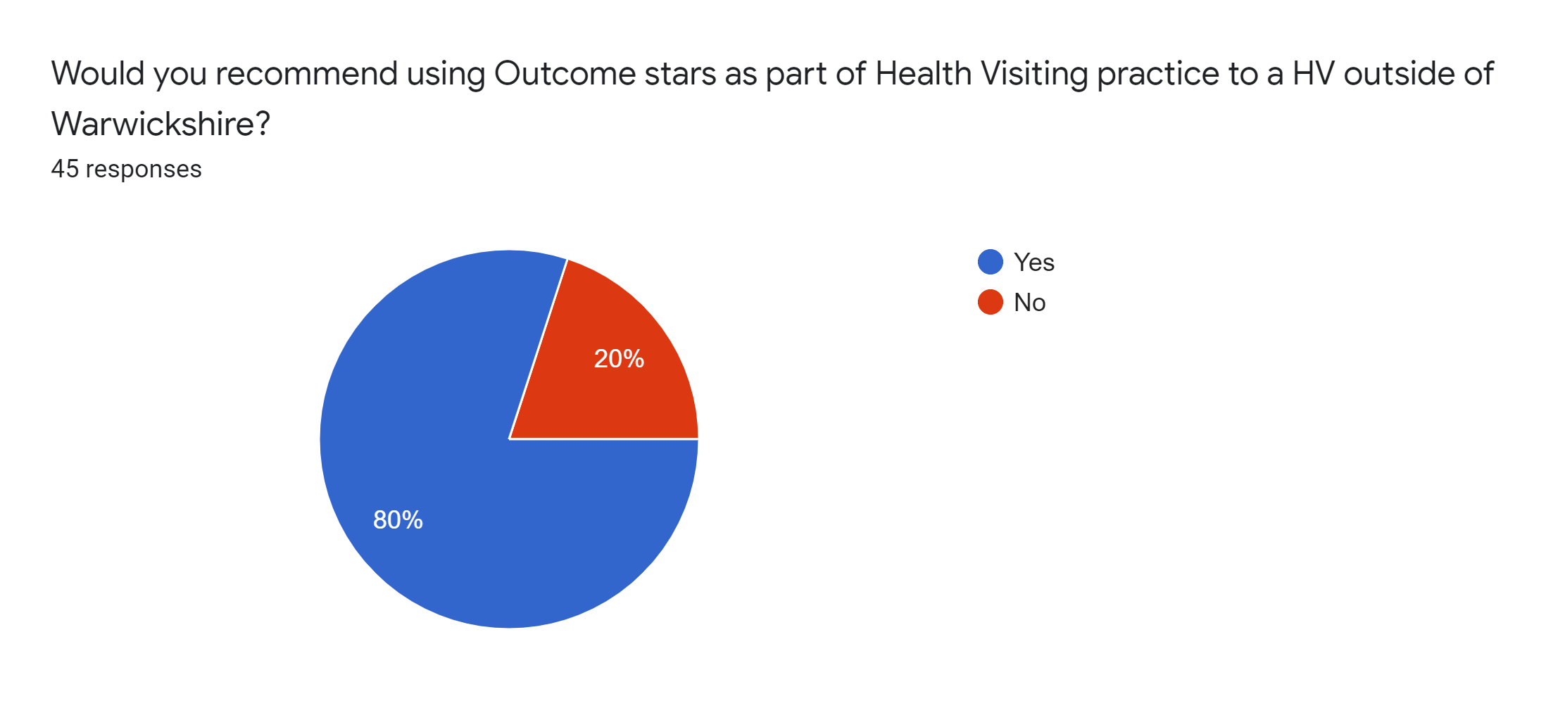
Yes =36 No = 9

This indicates that 80% of health visitors would recommend the use of outcome stars with families.

When asked how effective they have found the outcome star in identifying family’s needs at 6 weeks the following responses were submitted, see Diagram 5. The data was collected using a Likert scale of 1 to 5 with 1 being not effective and 5 being very effective.

Diagram 5:
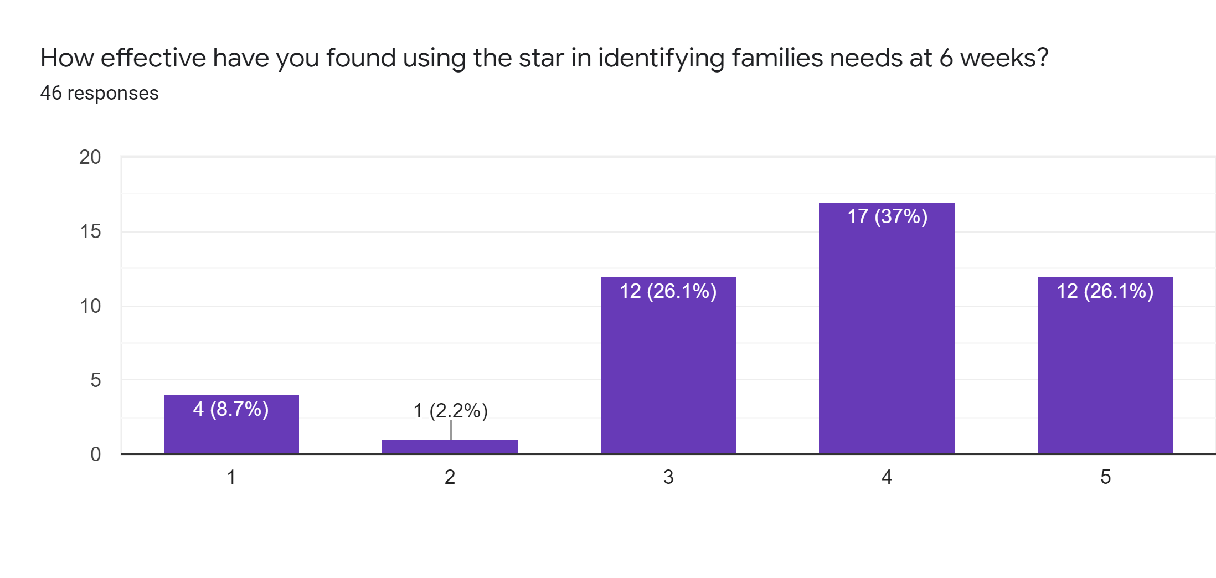
This indicated that 63% of health visitors found the star effective or very effective at identifying families needs at 6 weeks.

When asked if they have used the star with Dads as well as mums 23 (65%) said yes and 9 (35%) said no.

Of those who said no, the comments included:
- No, dads are usually not present at the 6 week visit
- no - dads rarely present at 6 week review
- I have with parents together, but I feel that doing this may change mum's responses as she may not be able to be honest if dad is present. Dads have looked at the Outcome Stars template, but they don't seem to feel that it relates to them.
- mainly mothers, I mainly see my mother's in clinic and most fathers have returned to work by then and don't accompany the mother by then.

Other comments around Dads being present and completing the star included:
- Dads have sometimes been present and have contributed. I think that having both adults present may mean that the mum is not as open about the relationship. I have had on 1 occasion a dad who totally disagreed with mum when she scored 5 for relationship and he said that he was really struggling with the changes. and scored much lower.
- yes, although I found it better, when dads weren't asked in front of their partners as they were more honest.
- Yes, this has prompted them to open up about their issues and feeling vulnerable and how it has changed their role within the family. They have felt they were listened to which was important. It also got parents talking about how they needed each other as support, as neither really knew what they were doing as parents.

When completing an Outcome star any family that scores 3 or below in any of the 7 areas should receive an action plan and a follow up visit.

Parent views on using the Parent & Baby Outcome star

While the audit only collected Health Visitors views directly, they were asked for feedback from families relating to the outcome star. The responses expressing families views fell into broadly three categories: positive, negative, and neutral. A summary of which are shown below:

Neutral:
- we don't often get feedback
- They have engaged in it well and I haven't had any criticism.
- it’s another tick list but can be useful as conversational guide.
- Have not asked as I explain what it is and why.
Negative:
- it is a tick box exercise
- I have a mum that I completed an outcome star at the 6 week appointment as standards dictate. The mum scored her mental health at a 2 at 6 weeks. This mum had already had Health visiting support from New Birth to 6 week check for her mental health. Mum stated that if she had had the outcome star discussion at the new birth it would have been a 1. The health visitor felt this was a missed opportunity to record the impact of the health visiting service.
- most see it as a pointless exercise. But some people have found a useful visual aid for progress that has been made.
- They generally view it dispassionately, as just another thing to be done. No-one has ever said it was helpful whereas feedback from my previous scorings was generally positive. Maybe it's me and my awkwardness with such a clunky tool but I don't find it useful or easy to use
- A lot feel that its more question etc for them to answer
Positives:
- They seem to really like it. The pictorial charts help to explain what it’s all about and within our discussion about how things are going it works well
- Very clear and easy to see progression (in either direction), it makes you think about things you might not have thought about otherwise
- It's made it easier to focus on the important issues and ask relevant questions.
- This has helped several parents’ communication. They have reported they have disagreed with each other about small things, but the facts have been they didn't really know what they expected of each other when the baby was born. Dads have felt a responsibility to earn more at work (do overtime) where mum's have felt left holding the baby and wished for dad to be a support. Others have reported they thought their partners (mum's) instinctively knew what to do with a baby, where mum's have felt they just had to get on and look after baby. When they talked, they both felt they understood each other better.
- have completed one very useful star where a whole host of needs were uncovered by using the pictorial guidance. Early Help was started as a result.
- Parent tell me: "it’s nice to see how well I am doing"
- Families do not have any issues with us asking these questions and it allows us to explore certain areas in more detail.
- It has been a way of asking family to think about their experience in past 6-8 weeks since newborn has arrived. Families are usually happy to complete questions if framed in sympathetic way. Most families say the experience of completing the star has been useful to them.
- They really liked it. People like to talk generally, and we are in a privileged position to be able to listen to them and identify need support and signpost on. Parents have said "that was really interesting to do" "That has made me think"
- Assisting parents to self-assess I have found really increases their confidence, breaks down barriers or aids further support being accepted.
- Feedback has been positive - parents have shared that it is easy, and some clients have shared that they recognise this as a positive change since they had their last baby
- They liked the approach that focused on them and it was a way of them communicating with their partner as well. When they compared their different scores, it opened them up to being more honest. A father stated he thought his partner knew how to look after the baby and was surprised she was struggling. Another felt their relationship had changed, as his partner discussed concerns with her mum, and he felt left out.
- More than one client has said that she felt that she mattered because 'it was not all about the baby'
- they have all accepted it and found it easy to understand
In summary it can be seen that the parent and baby star is well accepted by parents.

Staff views on the resources available to support the Outcome star implementation

We asked staff if they gave the leaflet about Outcome stars out at the new birth visit, as recommended in the SOPs. 74% of staff said they did, the majority who weren’t stated this was because they did not have access to leaflets, or had moved to telephone and video conferencing during Covid19.

The leaflet has now been made available to all staff to use electronically, so they can email it to families as needed or share when offering video consultations.

Staff views on if the star were being used at the right time to capture the work effectively with parents.

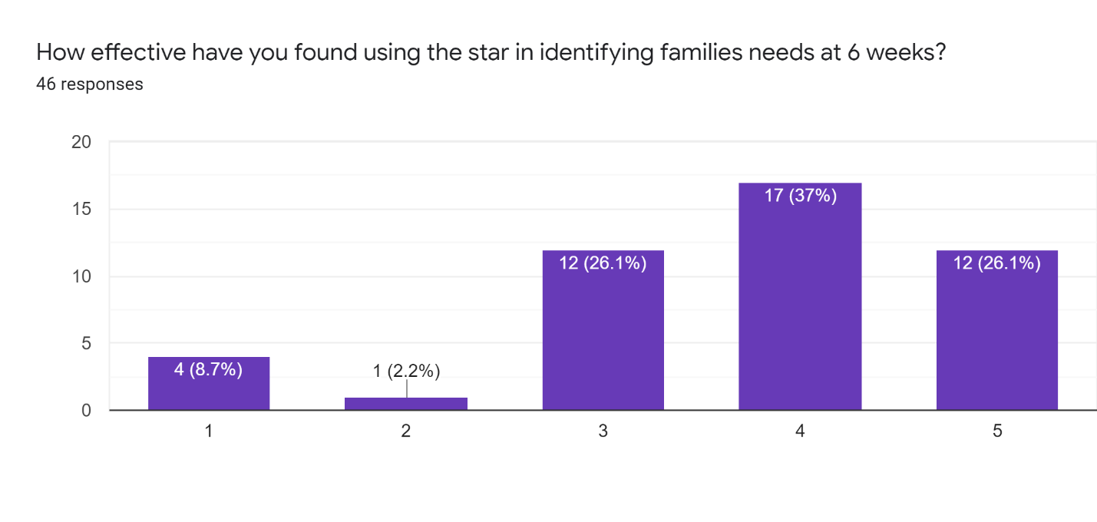
This showed that 63% of Health visitors said using it at 6 weeks was effective or very effective, 26% were neutral and 11% felt it wasn’t effective at 6 weeks.

When asked if they used the star at any other times and how effective had it been, the following responses were seen:
- It was more effective when used ad hoc rather than at 6 weeks when potentially you have already done lots of work.
- Yes. It focused the parents in a positive way and helped them see a way forward.
- Yes, at the new birth on occasions as mothers have felt overwhelmed having a baby and this has been really good to show the progress they have made and it helps boost them emotionally. I have also used them when mum's have reported they feel like they aren't coping and again when reviewed they can visually see they have moved on or they need more support from another source.
- Yes. It helps to capture the strengths and areas of need for families in a visual way. You can measure it again later to see any changes.
- No, we were advised to use it at the 6 week check to start with and in the future, it would be rolled out. However, I do see the merits of using it at A/N and other times where families are assessed to need further assessment. I have used it with Dads which has been positive - they really liked being involved and included
- Sometimes at the new birth visit as it has helped parents to be more aware of where they are emotionally and practically, and the Stars helps them to not feel so isolated and can generate more effective communication/understanding between them.

We asked staff what work they felt we weren’t capturing by just doing the parent and baby star at 6 weeks. Of the 28 responses the following themes were evident:
- It would be better to complete antenatally and followed up at postnatal visit (7 comments)
- Use a star when doing any support work for a family- as they are UP or UPP (4 comments)
- No gaps in collection (4 comments)
- It would be better to offer the star at more contacts but led by clients need for support (3 comments)
- We do a lot of work between new birth visits and 6/52 which isn’t captured (2 comments)
Other areas of work we could use outcome stars in
The following were shared:
- It may be useful to use an outcome star model with respect to specific support around high impact areas/interventions such as maternal mental health support, breastfeeding support, behaviour support, Healthy Weight (i.e HENRY programme -not sure how this is already measured) This could indicate more specific outcomes in relation to HV Team intervention.
- Further if the outcome star data is proving to be a useful measure of HV services it may be worth commencing stars at the beginning of UP and UPP HV interventions e.g. feeding/sleep issues, Early Help etc. and reassess at the end of the intervention.

When asked if they would trial new initiatives and feedback how these worked in practice, 13 Health visitors stated they would be willing to do this.

Audit review findings/ Conclusions

- 98% of Health Visitors who answered the questionnaire were using the outcome star with families at the six weeks postnatal review.
- 76% of Health Visitors stated that using the Outcome star gave a clearer picture of the lived experience of the family.
- 80% of health Visitors would recommend using the outcome star to Health visitors outside of Warwickshire.
- Health Visitors told us about the outcome star:
  - “It made it easier to focus on the important issues and ask relevant questions”
  - “The pictorial charts help to explain what it’s all about and within our discussion it works well”
  - Has helped several parents’ communication
  - It helps parents to self-assess, which increases their confidence, breaks down barriers and aids further support being accepted.
- Parents told Health Visitors:
  - “It helped me feel I mattered, as it wasn’t all about the baby”
  - “That was really interesting to do”
  - “That has made me think”
  - “It’s nice to see how well I am doing”
- When asked how effective it was as a tool at 6 weeks: 63% of HV said effective or very effective, others felt there was scope to use it more effectively. This included offering it earlier in the family journey and reviewing it at the six week postnatal appointment, using it at more contacts or using it for longer with more complex families receiving UP or UPP support.

